**Identity Column**

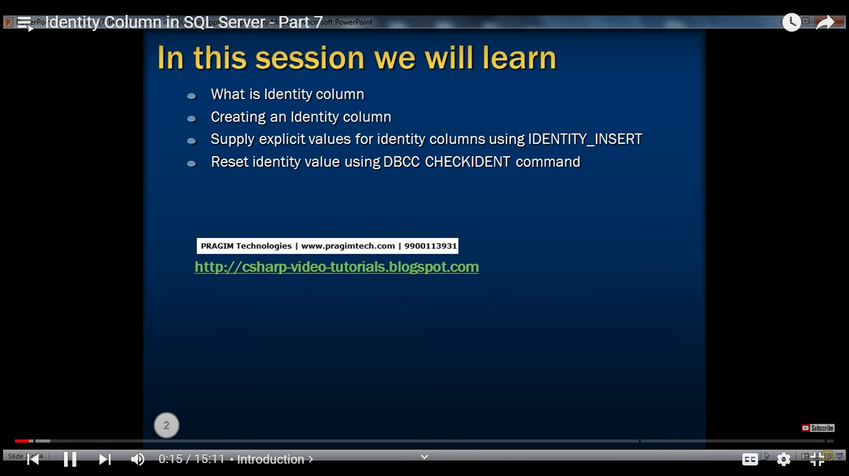

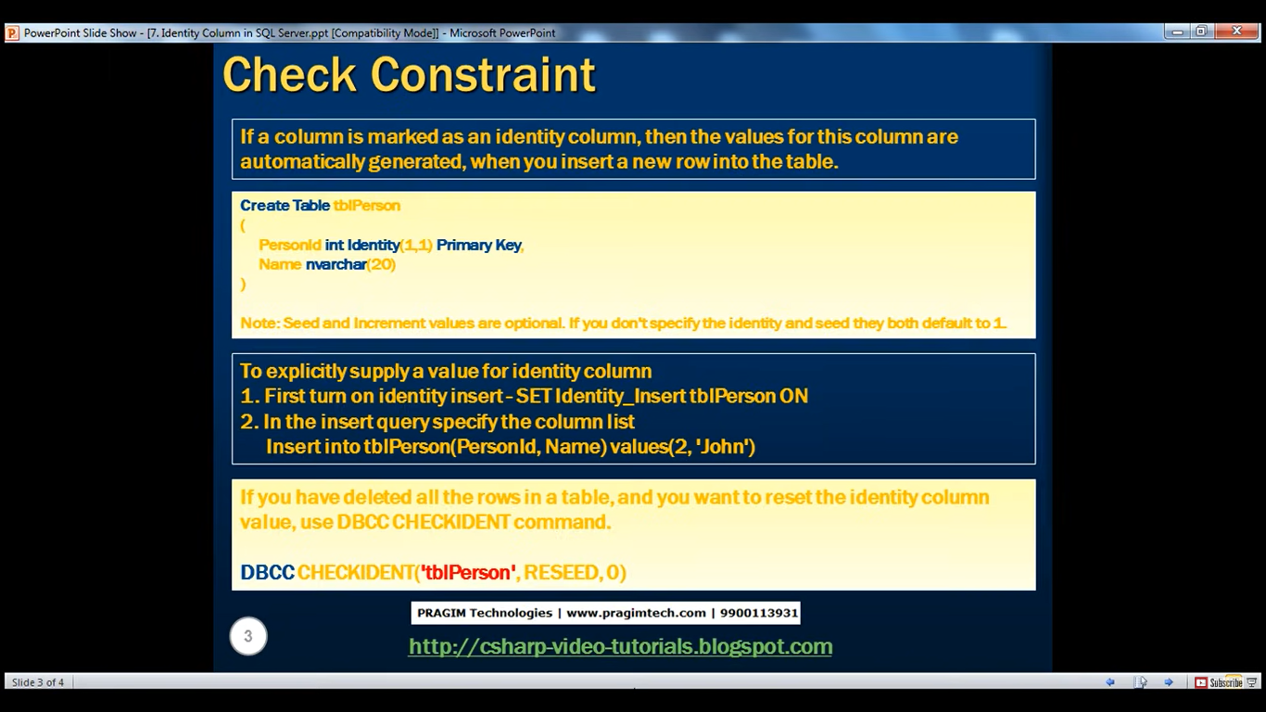

**For eg let’s take example of existing table tblPerson**

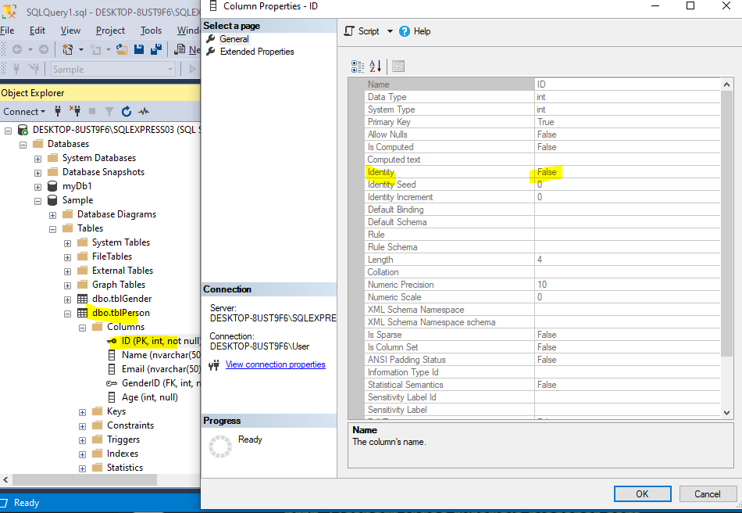

**In the above we can see Identity is false**

**Now let’s new table tblPerson1**

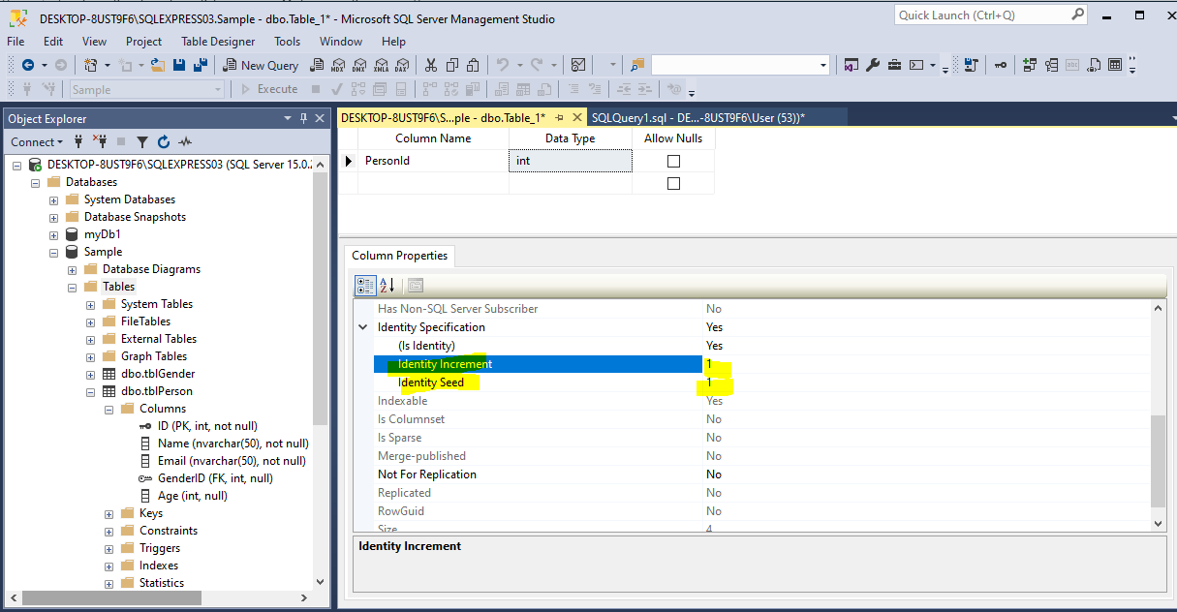

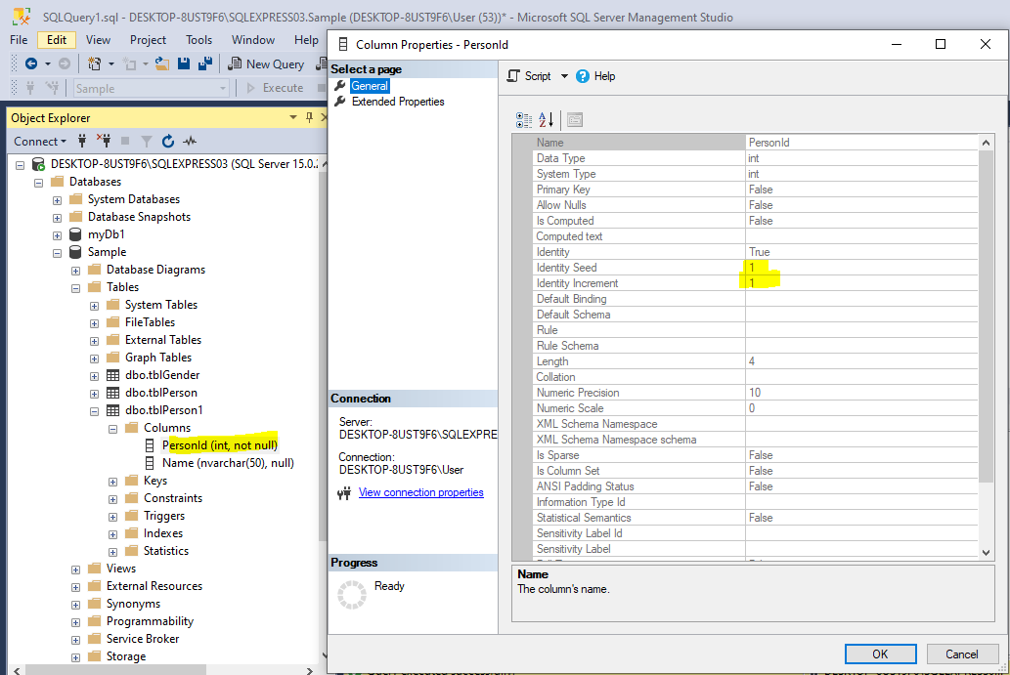

**Now since we have added identity column we are getting identity seed and identity increment**

**Identity Seed - First value**

**Identity Increment – How much increment should be there**

Insert into dbo.tblPerson1 values('John');

Insert into dbo.tblPerson1 values('Tom');

Insert into dbo.tblPerson1 values('Sara');

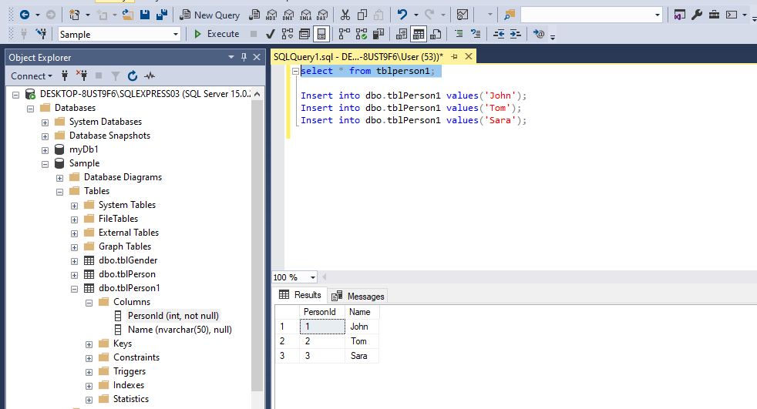

**Let’s say John left the organization**

Delete from tblPerson1 Where PersonId=1;

Now say if Todd joins

Insert into dbo.tblPerson1 values ('Todd');

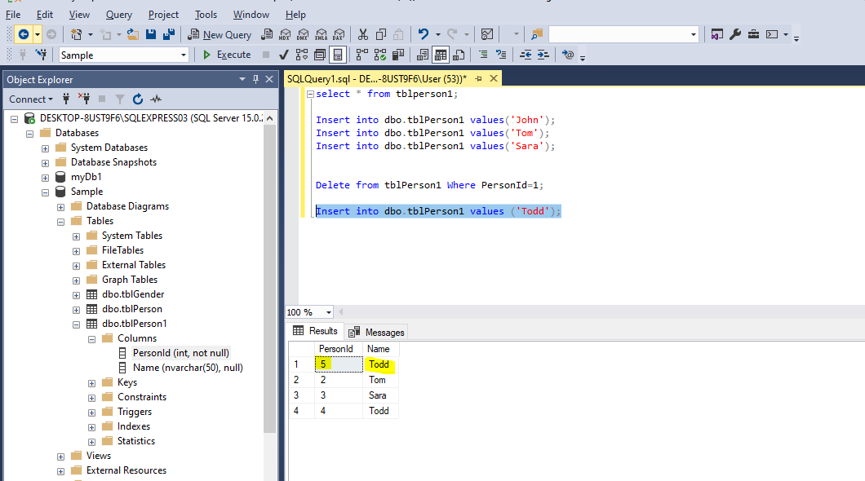

**We can see from above Todd is insert at column 5 instead of column 1. Now say suppose if I want to insert it at position 1.**

Insert into tblPerson1 values(1,'Jane');

Msg 8101, Level 16, State 1, Line 12

An explicit value for the identity column in table 'tblPerson1' can only be specified when a column list is used and IDENTITY_INSERT is ON.

Completion time: 2024-08-25T19:48:35.1535923+05:30

**So we cannot use like above**

**So we need to turn on IDENTITY_INSERT ON**

SET IDENTITY_INSERT tblPerson1 ON;

Insert into tblPerson1 (PersonId, Name) values(1,'Jane');

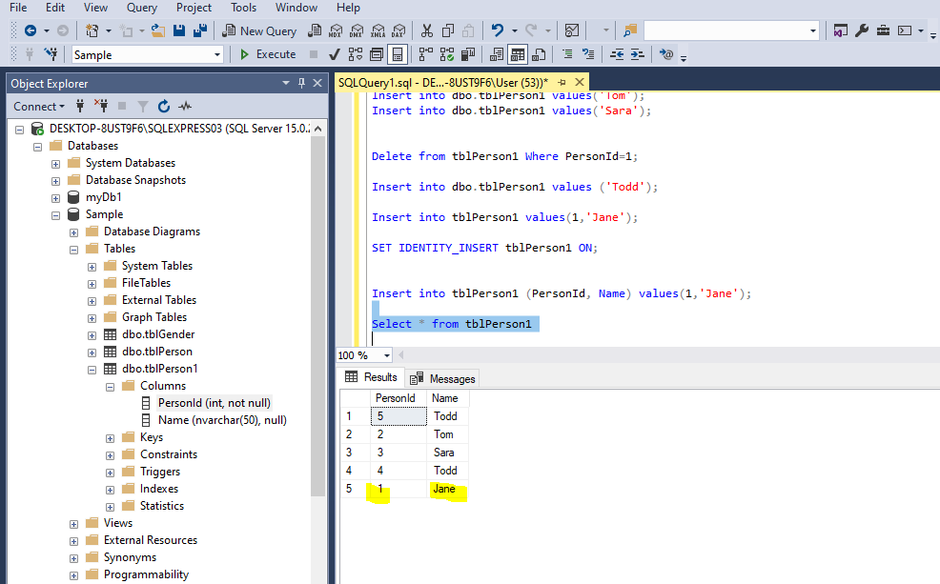

**Now if we insert the record without entering the id**

Insert into tblPerson1 values('Martin');

Msg 545, Level 16, State 1, Line 17

Explicit value must be specified for identity column in table 'tblPerson1' either when IDENTITY_INSERT is set to ON or when a replication user is inserting into a NOT FOR REPLICATION identity column.

Completion time: 2024-08-25T19:54:12.8462098+05:30

**So we need to turn off the IDENTITY_INSERT**

SET IDENTITY_INSERT tblPerson1 OFF;

Insert into tblPerson1 values('Martin');

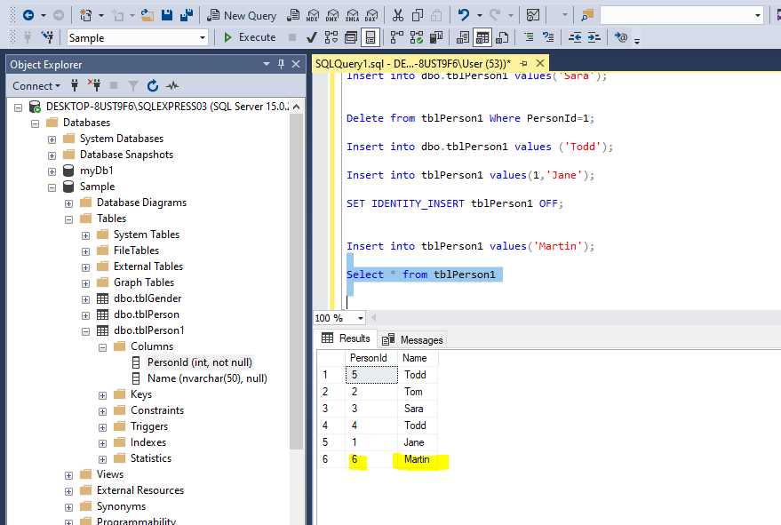

**Now if we delete the whole rows**

Delete from tblPerson1;

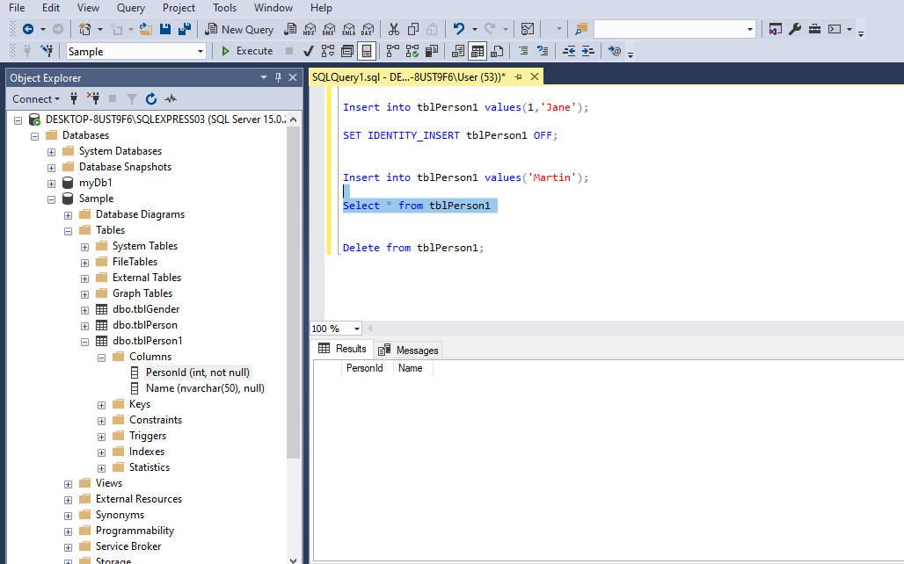

**Now if we add any data**

Insert into tblPerson1 values('Martin');

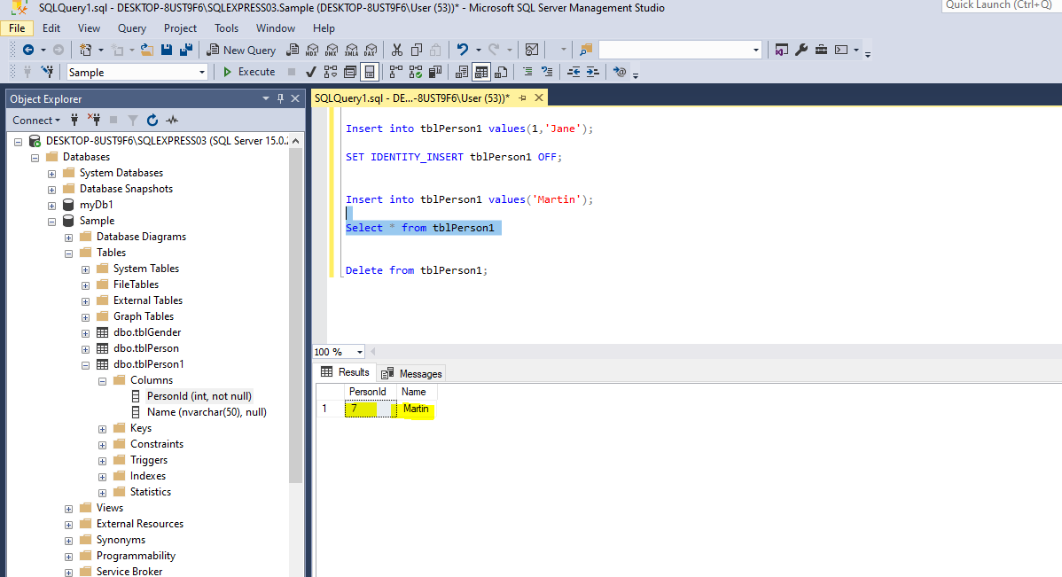

DBCC CHECKIDENT (tblPerson1, RESEED,0)

Checking identity information: current identity value '7'.

DBCC execution completed. If DBCC printed error messages, contact your system administrator.

Completion time: 2024-08-25T19:59:14.7281037+05:30

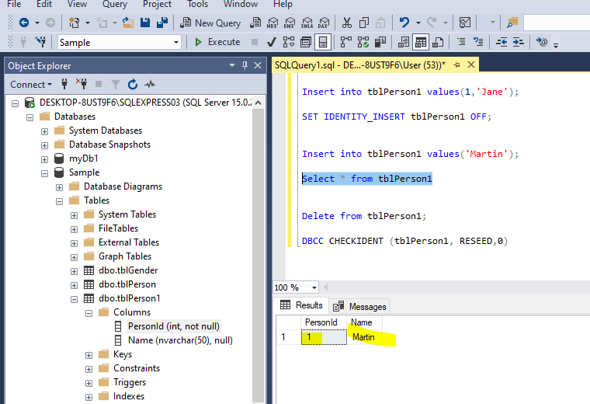

**So this will reseed the PersonId to 1.**

**DBCC – Database consistency check**

**Retreiving Identity Column Values**

